|  |
| --- |
| USER MANUAL |
| BioTrack Platform |
| Bank of Cyprus Oncology Center – Clinical Trials Unit |

|  |
| --- |
| 12-22-2022 |

Table of Contents

1.0 GENERAL INFORMATION 3

1.1 Platform Overview 3

1.2 Authorized Use Permission 3

2.0 Software Features 3

2.1 Login 3

2.2 Add new sample 4

2.3 Add a specimen 13

2.4 View/Edit Specimen 20

2.5 Specimen Logs 22

2.5.1 Specimen Registry Log 23

2.5.2 Specimen Storage Log 26

2.5.3 Downloading specific ICFs 29

2.6 Freezer Logs 30

2.6.1 -80oC Freezer Log 30

2.6.2 -20oC Freezer Log 31

2.7 Traceability Logs 31

Appendix 33

# GENERAL INFORMATION

## 1.1 Platform Overview

The BioTrack Platform is an online software that allows the registration and recording of the samples received, processed and stored in the laboratory at the Bank of Cyprus Oncology Centre (BOCOC) Clinical Trials Unit (CTU). Each sample received is registered in the BioTrack platform, along with the patient information (demographics, diagnosis, attending doctor, study the patient is participating in) and the sample information (sample type, quantity, collection time etc).

The BioTrack platform was developed to ensure that all the samples stored in the laboratory are properly registered and can be tracked at any point in time, as well as to keep a database of the types of samples stored. The goal is to create an electronic database of all the samples stored which can be used in future research projects and clinical trials.

## 1.2 Authorized Use Permission

The BioTrack platform is accessible only from the BOCOC server and a password and username is required to access the platform. Only authorised laboratory personnel are issued with log in credentials.

# Software Features

## 2.1 Login

By logging in, you will be allowed to create new records. Only the admin can modify the existing records.

1. Open Google Chrome, enter the web address below and press **Enter**.

<http://192.168.0.62:3838/BioTrack/>

The login screen is displayed as shown below.

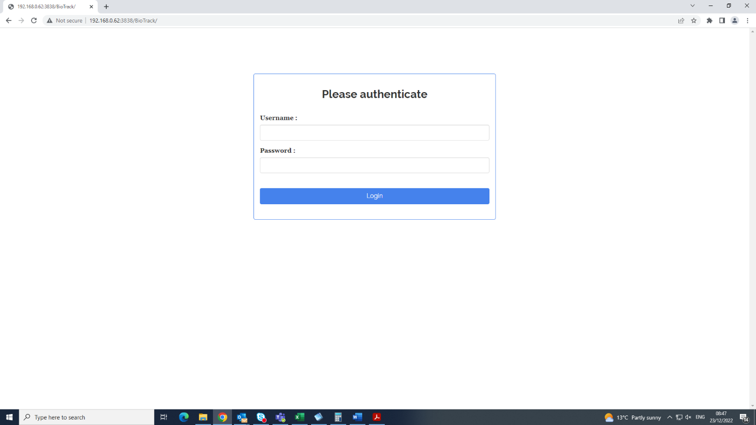

1. Type the **Username** and **Password.**
2. Click the Login Button.

## 2.2 Add new sample

After successful login, the sample information screen is displayed.

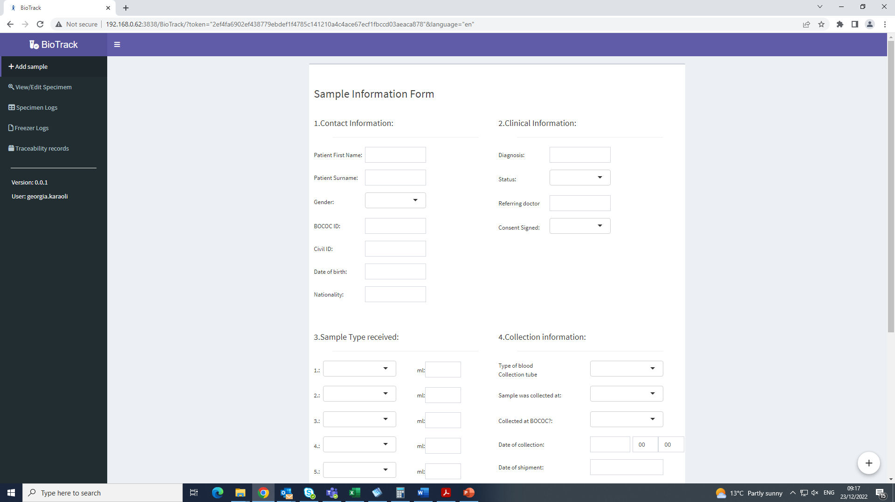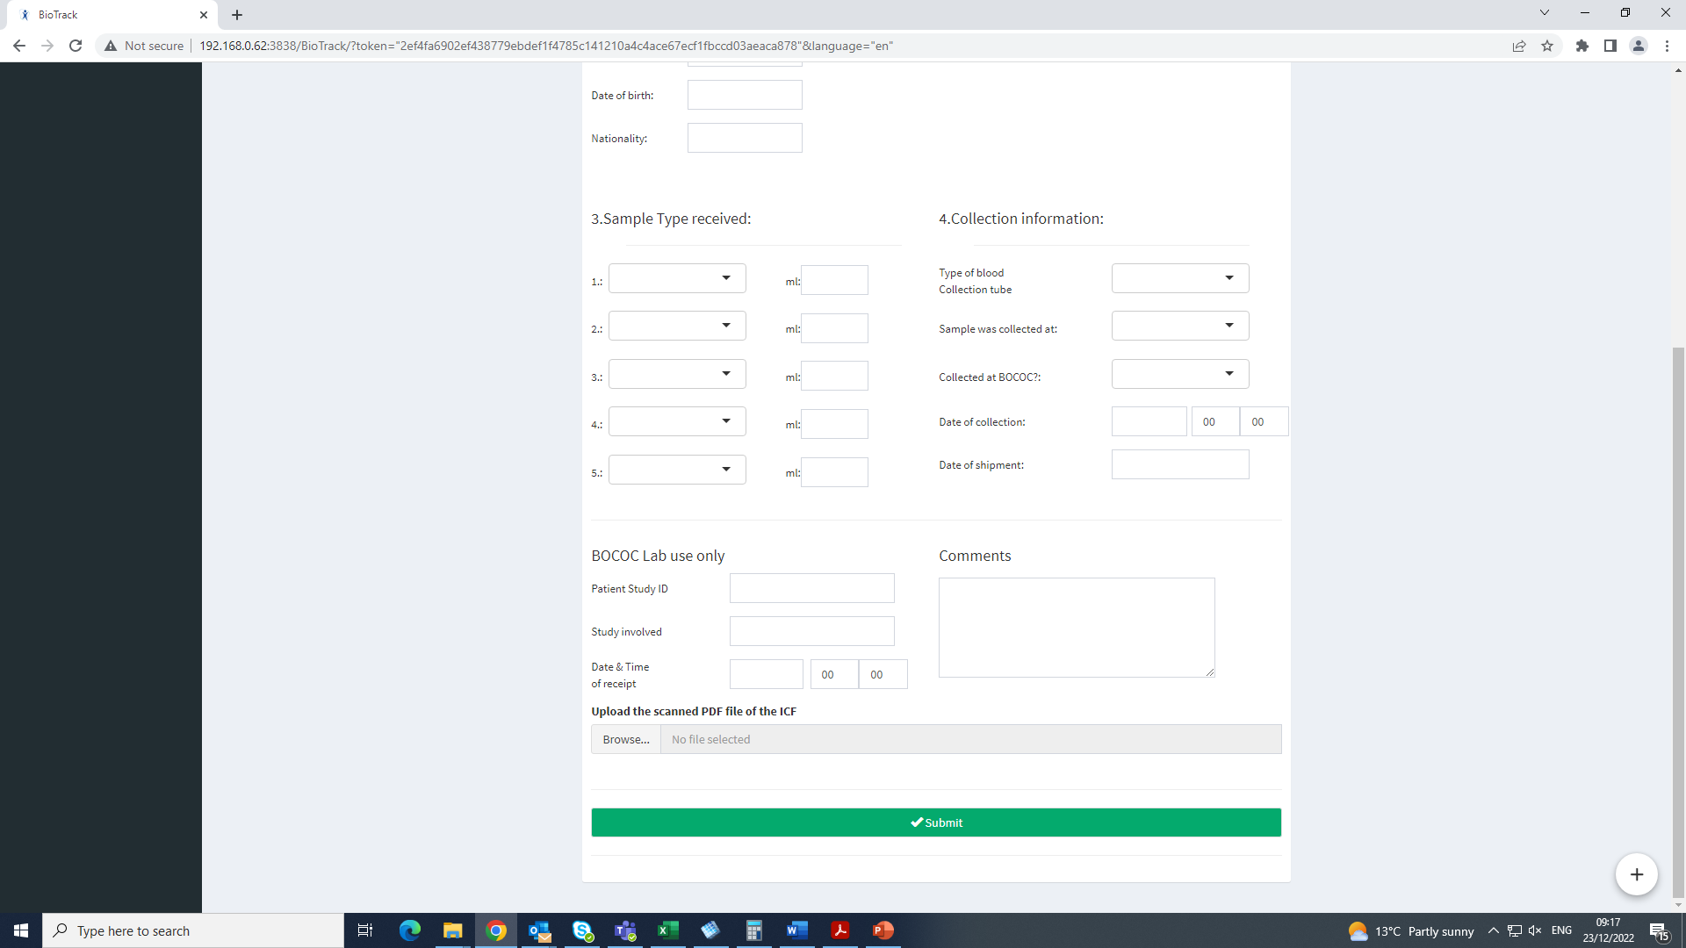

1. Section 1 requires the completion of the demographic details of the patient. The fields to be completed are shown below. This information can be found in MOSAIQ.

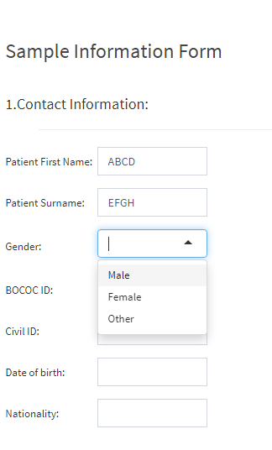

**A**

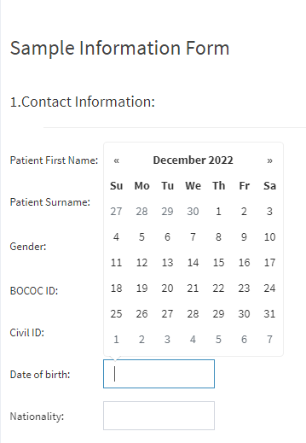

**B**

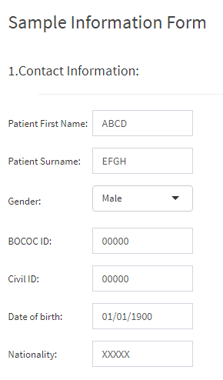

**C**

1. Section 2 requires the completion of the clinical information of the patient. This information can be found in MOSAIQ.
2. Enter the type of cancer in the diagnosis field.

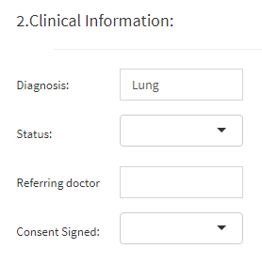

1. Graphical user interface, application

   Description automatically generatedChoose the Status from the drop-down list. *This field is* ***not mandatory*** *to be filled at the time of sample entry.*
2. Enter the name of the patient’s referring doctor in the relevant field.

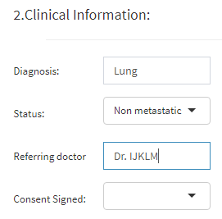

1. Choose from the drop-down list if the patient has signed a consent form.

1. Graphical user interface

   Description automatically generatedIn section 3, the type of sample must be entered, by selecting the appropriate option from the drop down list provided. The quantity in ml is entered manually where applicable. The BioTrack platform allows the user to enter up to 5 sample types for each collection. *All fields in this section are* ***mandatory*** *except the “ml” fields.*

1. Section 4 requires the collection information.
   1. The user must select the type of collection tube from the drop-down list provided.

* 1. The time point of collection must also be selected. In case the “Other” option is selected, a comment box automatically appears to allow the user to enter manually the timepoint.

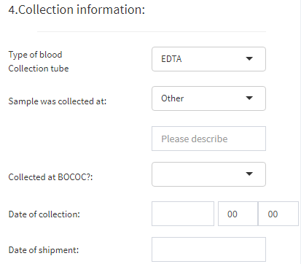

* 1. The Collected at BOCOC field needs to be completed either with “Yes” or “No”.

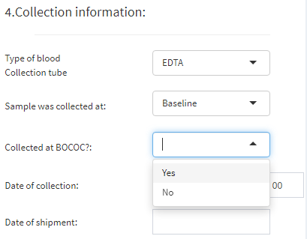

* 1. The Date of Collection is selected from the calendar provided and the time of collection is also entered.

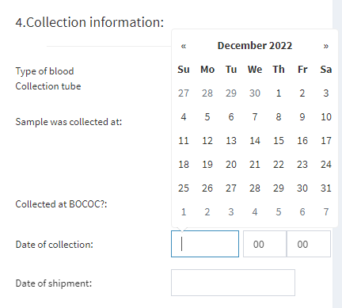

* 1. Where applicable, the date of shipment is also entered. *This field is* ***mandatory*** *if at the “Collected at BOCOC” field “****No****” is selected. If at the “Collected at BOCOC” field “****Yes****” is selected, then the Date of shipment is* ***not******mandatory****.*

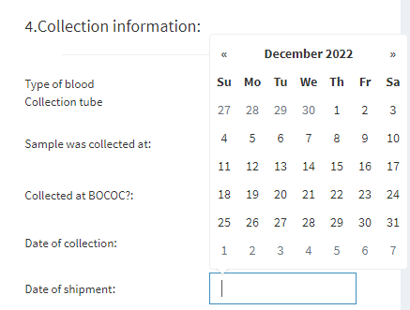

1. After completing all the sections above, you move on to the BOCOC Lab Use only section. *All fields in this section are* ***mandatory****.*
   1. Enter the Patient Study ID of the patient whose sample is being registered.

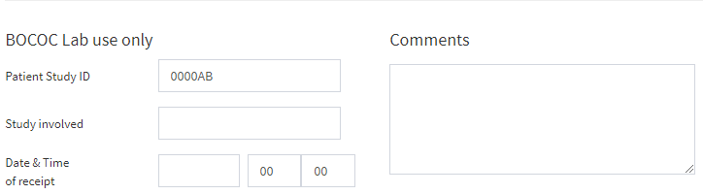

* 1. Enter the name of the Study the patient is participating in.

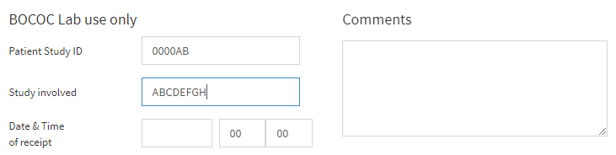

*In the case that the patient is not involved in any study, both the “*Patient Study ID*” and “*Study involved*” fields must be filled with “**None**”.

* 1. Enter the Date and Time of receipt of the sample at the laboratory.

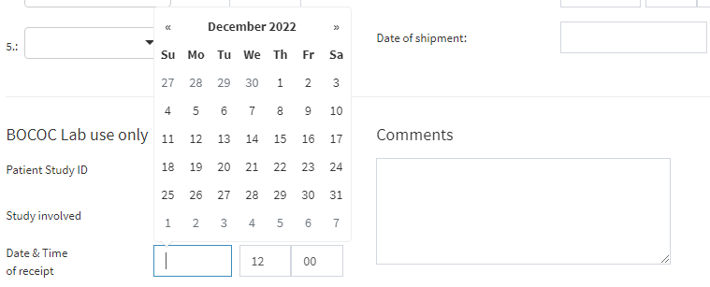

1. The final action before submitting the new sample in the BioTrack platform is to upload the scanned PDF file of the ICF.
   1. 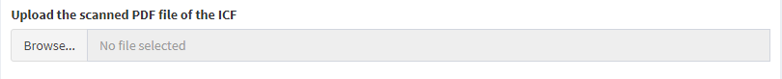Click on Browse
   2. Graphical user interface, text, application

      Description automatically generatedA dialog box opens which allows you to navigate your folders and select the appropriate file.
   3. Once you select the file, click on open.

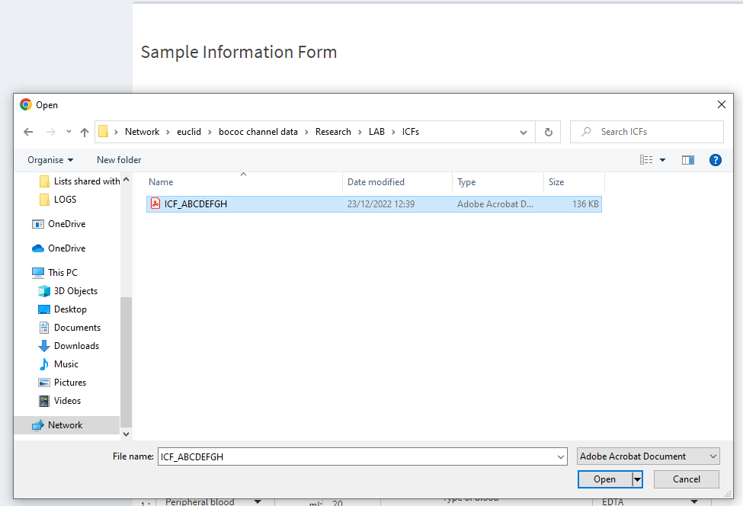

* 1. Graphical user interface, timeline

     Description automatically generatedThe system will show you whether the upload was successful. More than 1 PDF documents can be uploaded for each sample.

1. When all the information is entered, click on “Submit”.

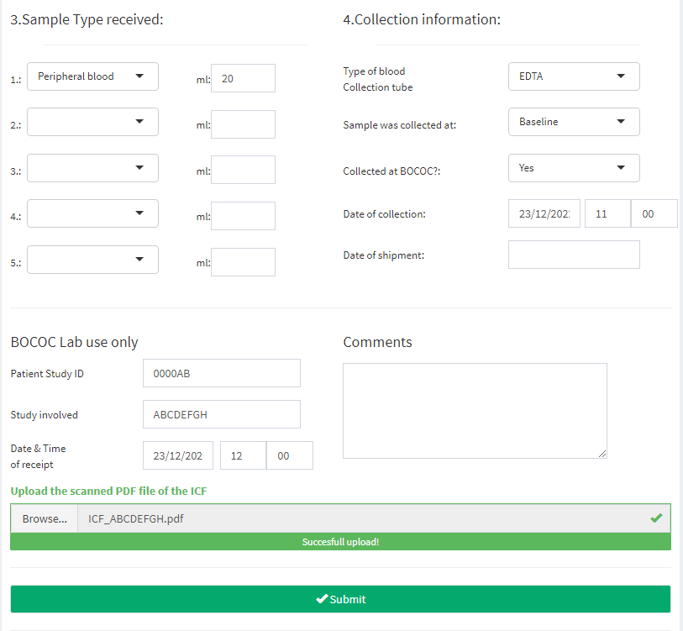

## 2.3 Add a specimen

1. After clicking Submit, the user is directed to a new page titled “Processing / Storage Information”. This is the page where the specimens processed and stored for the sample entered will be registered.

1. Click on Add a specimen to add the type and quantity of specimens processed in the laboratory.

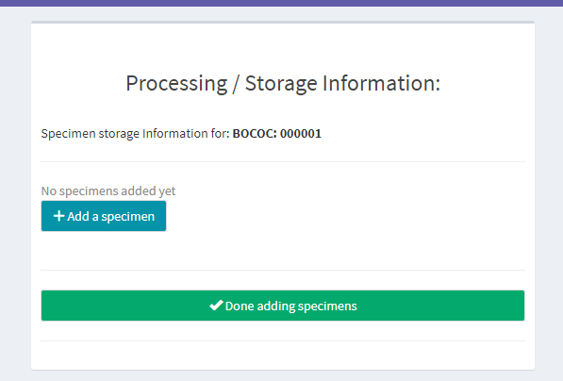

1. Graphical user interface, website

   Description automatically generatedThe Add a Specimen dialog box opens.
2. Select the specimen type from the drop-down list.

1. Enter the Sample Quality.

1. Enter the Date and Time of processing.

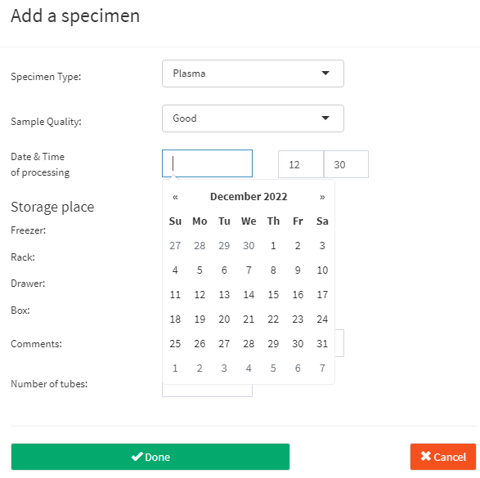

1. Select the storage location of the specimen processed by selecting the freezer, rack, drawer and box.

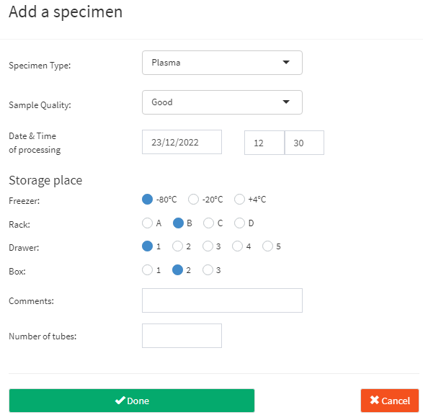

1. Enter the number of tubes stored and click on **Done**. If any comments are needed for the specific specimen, they can be entered in the comments box.

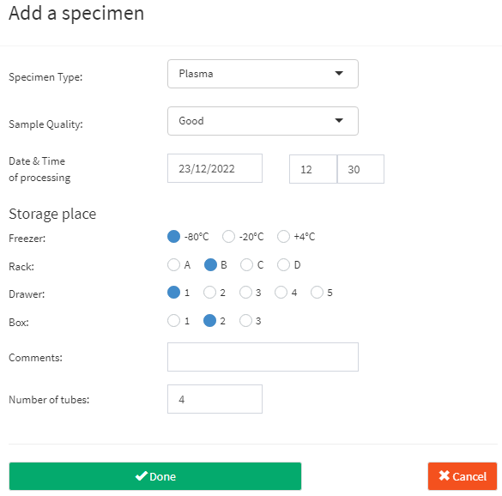

Note 1: The racks and boxes can only be selected if the -80OC freezer is selected. They become locked if either the -20 OC or the +4 OC freezer are selected (shown below).

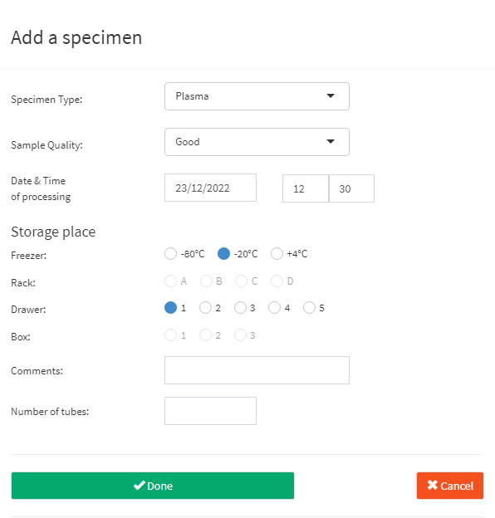

Note 2: The date of processing needs to be the date of entry. The BioTrack platform does not allow you to proceed if you select a future date (shown below):

1. A picture containing table

   Description automatically generatedAfter clicking Done, the processing/storage screen appears again, showing the specimen you entered, along with the unique Lab Number generated by the system and the storage details. The Lab Number is generated automatically by the system and indicates the year, the number of specimen and the specimen type.

Indicates the year of entry. For this specimen, the year is 2022.

Sequential number of the specimen. This number is increasing sequentially with every specimen added.

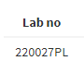

Code which corresponds to the specimen type. This case is for a plasma specimen.

1. You can add multiple specimens for each sample received and processed by clicking on add specimen.

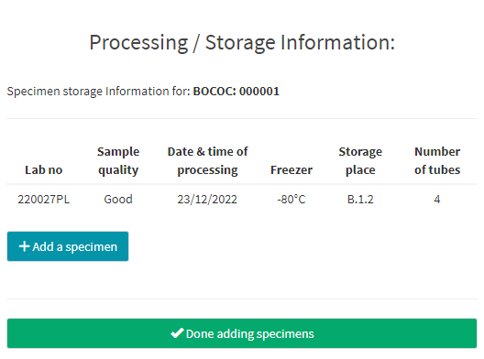

1. When you are done adding specimens, click on **Done adding specimens**.



1. After clicking on Done adding specimens, the system redirects you to the initial Add sample page.

## 2.4 View/Edit Specimen

To view or edit a specimen, search with the unique Lab number of the desired specimen, or scan the barcode found on the tube of the specimen.

Once the Lab number is entered in the search bar, the specimen details along with the sample information will appear.

To edit any field, you need to click on this icon.

A simple user can **only edit** the Number of tubes and Status fields.

When the change is made, click on **Done**.

If a user attempts to edit any of the other fields, then an error message appears.

**Only the administrator** can edit the rest of the fields.

## 2.5 Specimen Logs

Clicking on the Specimen Logs tab on the side bar will direct you to the **specimen registry log** and **specimen storage log**. These logs show all the specimens entered in the system in a tabular form and can be exported in excel format for further manipulation of the available data. These logs also provide the ability to download the ICF(s) for a selected specimen in PDF format. There 2 tabs, one for each log.

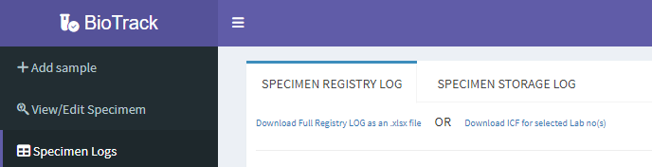

### 2.5.1 Specimen Registry Log

The Specimen Registry Log shows all the information about the sample entered upon receival of the sample in the lab (section 2.2). The information can be filtered using the filtering fields provided (circled below). You can use either 1, 2 or all 3 of the filtering fields.

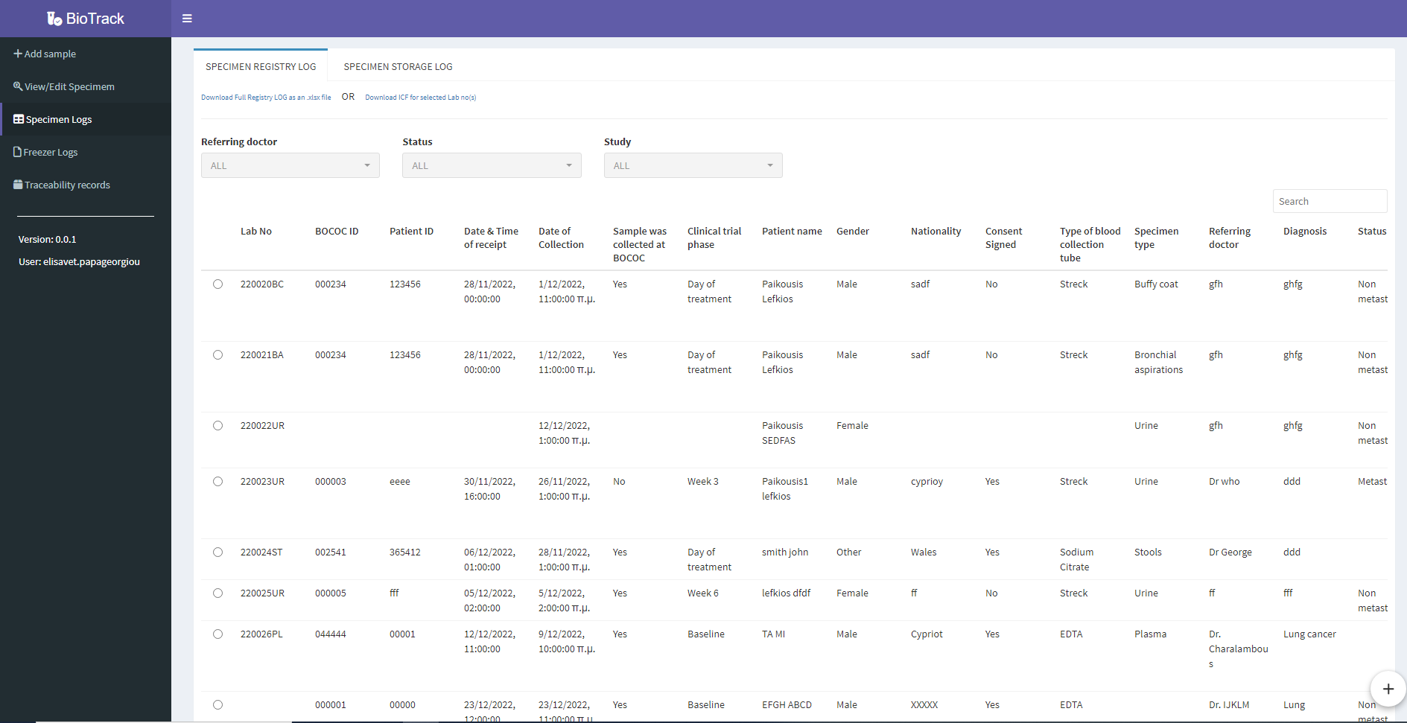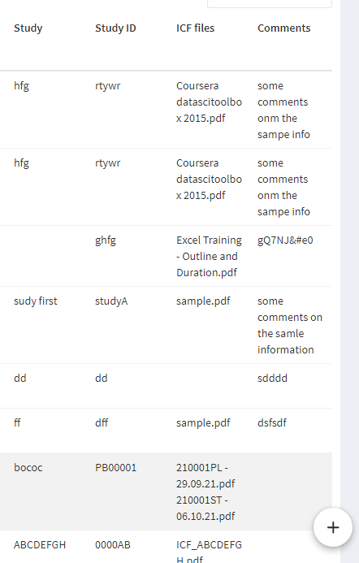

Only the results of the filtering will be displayed in the table and only those results will be exported in excel (see figures below).

By clicking on the Download Full Registry LOG as an .xlsx file, only the filtered entries will be exported.

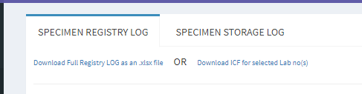

Otherwise, no filters can be selected, and the full Registry Log can be exported to excel by clicking on the Download Full Registry LOG as an .xlsx file.

### 2.5.2 Specimen Storage Log

The Specimen Storage Log shows the samples processed and stored in the laboratory. This log indicates the date and time of processing, collection, and receipt, along with the specimen type, storage place and number of tubes stored.

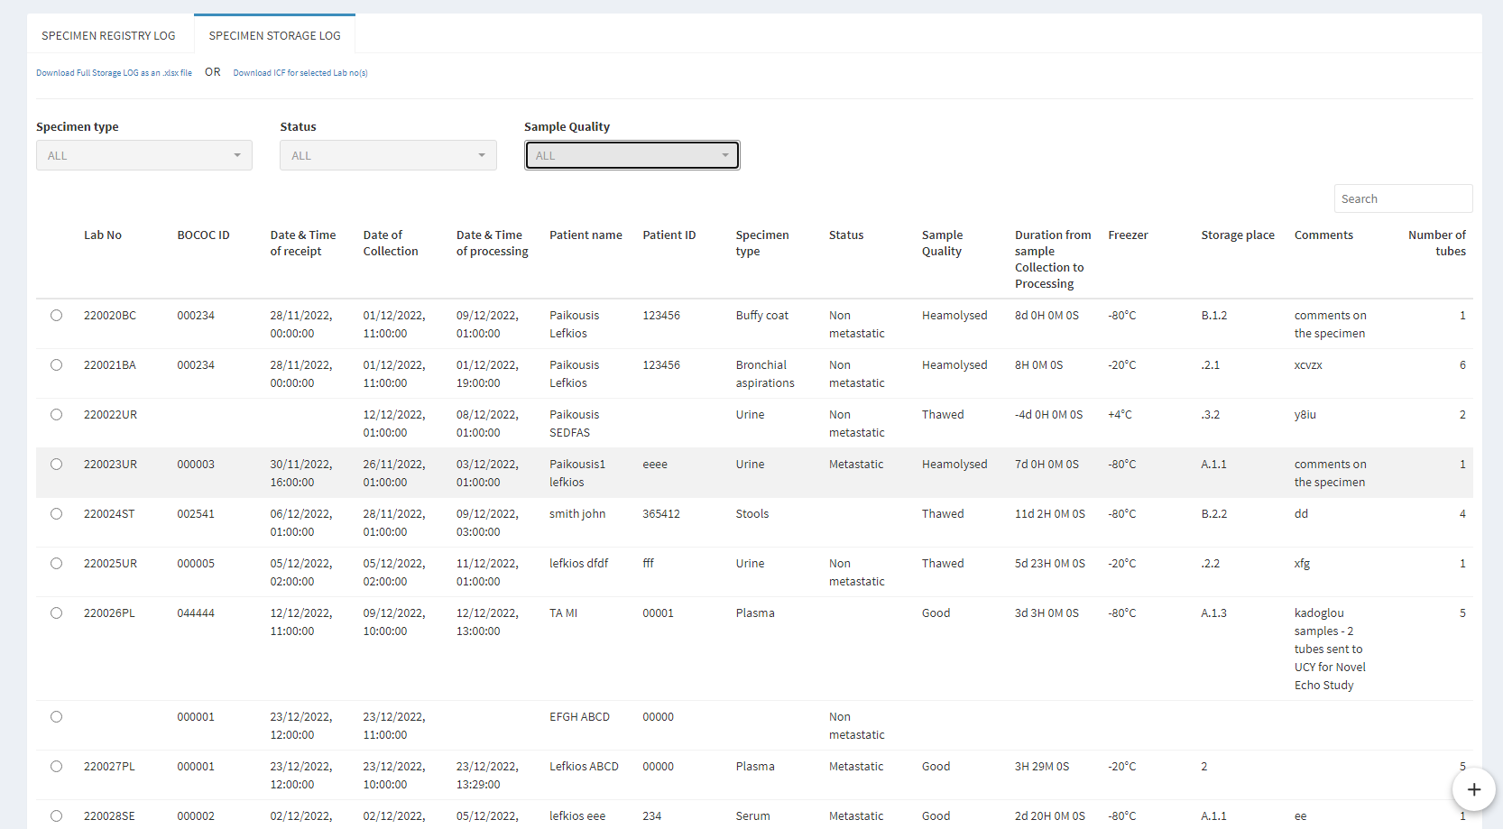

The Specimen Storage Log also provides the option to filter the results displayed on screen (circled below).



As in 2.5.1, the user can select either 1, 2 or all 3 filtering fields to filter the data and export only the selected entries.

By clicking on the Download Full Storage LOG as an .xlsx file, only the filtered results are exported. Otherwise, if no filters are applied, all the results are exported.

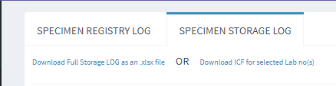

### 2.5.3 Downloading specific ICFs

The ICF for a selected sample can be downloaded as PDF, by selecting the sample and clicking on Download ICF for selected Lab no(s). Only one ICF can be downloaded at a time. The sample can be selected either from the Specimen Registry Log or the Specimen Storage Log.

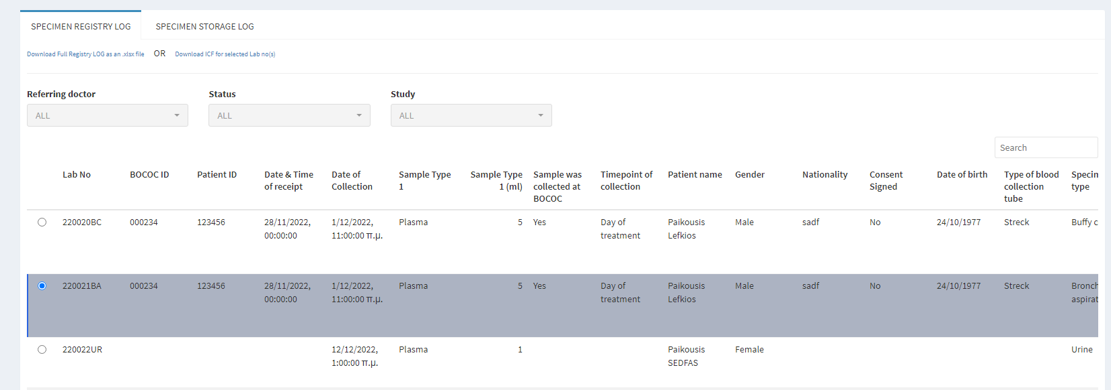

## 2.6 Freezer Logs

The Freezer Logs show the positions the samples are stored. Each freezer has its own log, along with its specific design. The freezer logs can be accessed by clicking on the Freezer Logs tab on the side bar.

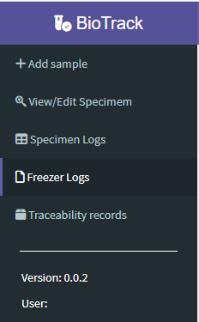

### 2.6.1 -80oC Freezer Log

The -80oC freezer has a specific design. There are 4 racks (A, B, C and D), and each rack has its own drawers and boxes. There are 5 drawers which can store 3 boxes each. Each rack can be selected from the drop-down list provided. The log displays each rack separately and the Lab number of the samples stored in each box are shown in the respective field of the log.

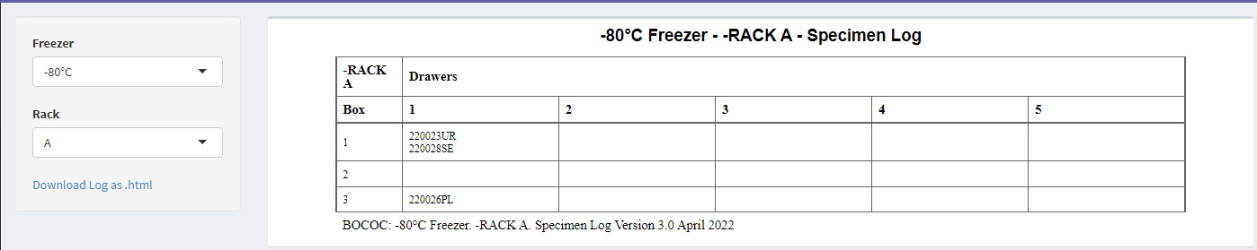

### 2.6.2 -20oC Freezer Log

The -20oC freezer has a different design than the -80oC freezer. It can be selected to be displayed on screen by selecting it from the drop-down list. This freezer has only 5 drawers, so the “Rack” option is locked, and the user cannot select a rack. The Lab number of the samples stored in each drawer are shown in the respective field of the log.

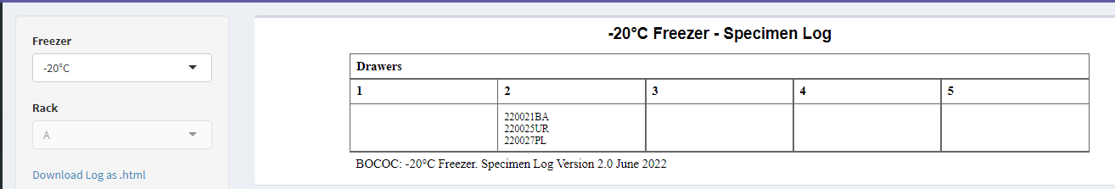

## 2.7 Traceability Logs

This log is used for traceability purposes. Each action that takes place in the platform from all users, is recorded in this log, along with the time stamp of the action and the description of the action which took place. This log can be accessed by clicking on the Traceability Records tab on the side bar.

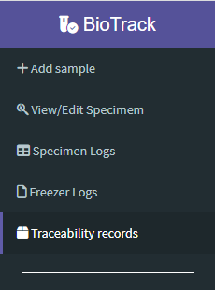

The traceability records log is displayed as shown below.

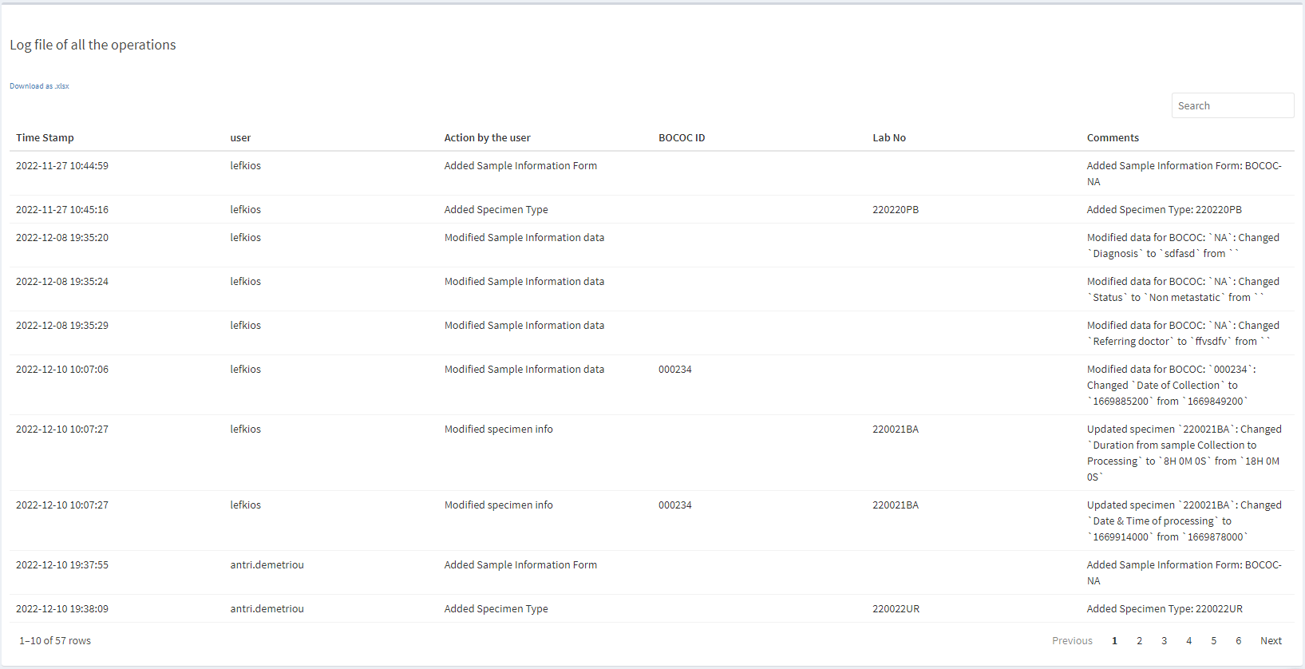

# Appendix

1. When “Bronchial aspirations” are selected as the sample type received, before submitting the Sample information form, the user should write in the comment box the type of bronchial aspiration collected (BAL, BAS, Transbronchial biopsy).
2. In the “Referring doctor” field, the user should always write “**Dr. (doctor’s surname)**” to ensure uniformity during filtering.
3. In the “Sample collected at” field, when “Other” is selected, the user should follow the guidelines provided for each study. These guidelines are found within the laboratory.